**Day-5 #Task**

Q2 create a user in linux with userid as 10001

- Add the user into the secondary group {sales} at time of creating the user

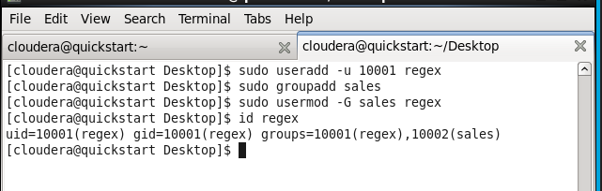

Q3: Try to move the file from local environment to any folder into hadoop ecosystem.



Q4: create a empty file in any location in Hadoop

-bash-4.1$ hdfs dfs -touchz /user/cloudera/text.txt

Q5 Change the permission of the folder & the files & subdirectories present inside the location of hadoop

- After that also verify the folder & also the internal files inside the folder

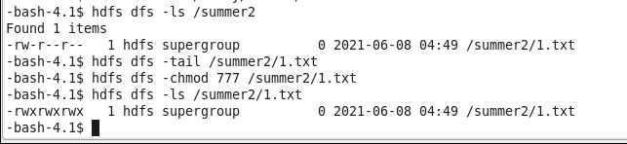

Q6 change the replicaiton factor for any file present in hadoop to 3

- Also change the replication factor for any file while using the {put command } in hadoop to 3

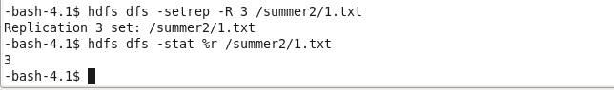

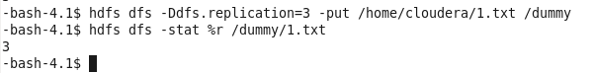

Q7 - Create any folder in hadoop

- Move the file from local to hadoop folder

- create one more file with data into local linux

- Try to copy the contents of new file from local machine to the hadoop environment now in the same folder

